Lock Position

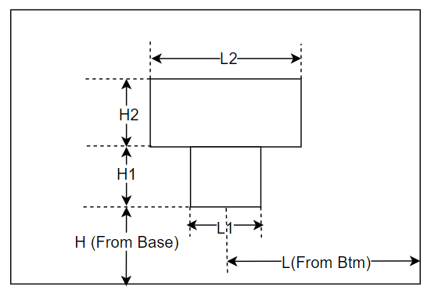

SDF: Lock Position

**Variable**

|  |  |  |
| --- | --- | --- |
| **No** | **Parameter** | **Value/Equation** |
| 1 | L | Strike Height |
| 2 | H | Return1 + Architrave1 – 3.9 |
| 3 | L1 | 38.5 |
| 4 | H1 | (Rebate1 > 48) 11/9 |
| 5 | L2 | 70.5 |
| 6 | H2 | 29 |

|  |  |
| --- | --- |
| Class | Method |
| HingeTools | DrawLockProfile() |